Step 5
There are three high-level IMMA data formats, which are U.S. state crime rate data (CSV format), U.S. state earthquake data (JSON format), and U.S. suicide mortality statistics (XML format).
1. U.S. state crime rate data (CSV format)
U.S. state crime rate data (CSV format) is linked to the Haunted Places dataset via state abbreviations (state_abbrev). Specifically, the cities where the FBI offices are located in the crime rate data for each state in the United States are mapped to the corresponding state abbreviations to accurately match the original data. 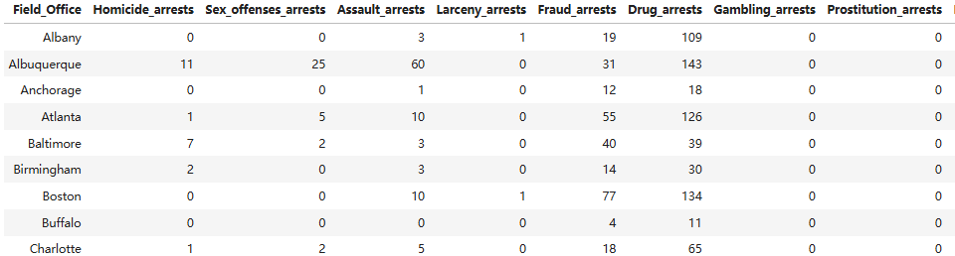 In addition, we additionally extracted and calculated the following three characteristics from the crime dataset: violent crime rate (per 100,000 people), property crime rate (per 100,000 people), and total arrests. The following is a screenshot of some of the data obtained after the calculation and summary.
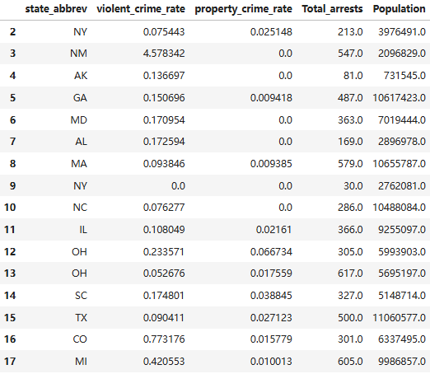

Feature Name | Description | Queries it can answer | Calculation Method
violent_crime_rate | Number of violent crimes per 100,000 people in the state | Do ghost sightings occur more frequently in areas with higher violent crime rates? | Violent crime rate = (Murder + Sexual offenses + Assault) / Population × 100,000
property_crime_rate | Property crime occurrences per 100,000 residents | Are ghost sightings associated with areas that have high property crime rates? | Property crime rate = (Number of larceny arrests + Number of motor vehicle theft arrests + Number of vandalism arrests) / Population × 100,000
total_arrests | Total number of arrests made in the state for the given year | Are ghost sightings related to the law enforcement activities (number of arrests)? | Total number of arrests recorded within the state (provided by the dataset)

- U.S. state seismic data (JSON format)
There’s using a seismic dataset (JSON format) that contains latitude and longitude, magnitude, time, etc. of the earthquake. The seismic dataset is connected to each location in the Haunted Places dataset by latitude and longitude geospatial coordinates (based on proximity within 20 km). The dataset I joined contributed the following three characteristics.
Feature Name | Description | Queries it can answer | Calculation Method
recent_earthquake_count | Number of earthquakes occurring within 20 km radius of the haunted location | Are ghost sightings associated with frequent local earthquake activity? | Count earthquakes within 20 km radius of each haunted location
recent_earthquake_max_mag | Maximum magnitude of earthquakes within 20 km radius of the haunted location | Do ghost sightings tend to occur in areas experiencing recent strong earthquakes? | Extract the highest magnitude from earthquakes within a 20 km radius
recent_earthquake_latest_time | Date and time of the most recent earthquake | Are ghost sightings related to the timing of recent earthquake occurrences? | Extract date and time of the most recent earthquake event within the required radius

- Statistical information on suicide mortality in the United States (XML format)
The XML dataset is the U.S. Suicide Death Rate, which is linked to the Haunted Places dataset using the State. The following three features were extracted from the XML dataset.
Feature Name | Description | Query it can answer | Calculation method
historical_suicide_avg | Average suicide rate per 100,000 people in the state over the past 10 years | Do states with higher suicide rates have more ghost sightings? | Calculate the average suicide rate over the past 10 years
latest_suicide_rate | Suicide rate per 100,000 people in the state for the most recent year | Is the latest suicide rate associated with recent ghost sightings? | Directly extract the data from the most recent year
suicide_rate_trend | The trend (increase, decrease, or stable) of suicide rate in the latest year compared to the average of the previous 5 years | Is the suicide rate trend associated with the frequency of ghost sightings? | Compare the most recent year's suicide rate with the average of the previous 5 years

